BYOC_HW2:

Tsahi Barshevsky 311334544

Kostya Lokshin 310765821

3.1) Draw on paper a block diagram describing the inside of HW2_top entity. Specify all

connections of the sub components between themselves and between them and the i/o pins

of the HW2_top entity. [This is meant to make you familiar with the i/o pin names, the signals,

the port mapping of the components, i.e., to understand what is connected to what]

It is similar to HW2_top seen in Fig.2 of this document except you are not supposed to show

the inner parts of the components (e.g., the Fetch_Unit), and you are supposed to show **all**

signals and i/o pins of HW2_top and all components inside HW2_top. The i/o pins names of a

component should be written inside the component (e.g., CK_25MHz_OUT in the

Clock_Driver). The HW2_top i/o pin names should be written outside the HW2_top entity.

The signal names should be written next to the signal wires. You should gather bus lines

together and specify them accordingly (e.g., bus(15:0)_example for the signals

bus0_example, bus1_example, … , bus15_example). You may base your drawing on Fig.2 of

the 14_BYOC_HW_infrastructure.doc file.

3.2) You need to attach a doc file with screen captures describing the simulation you made.

All signals mentioned in section 1a above should be presented in the screen capture. Show

at least the 1st 10 ck cycles following the end of the reset pulse and make the values of all

signals readable.

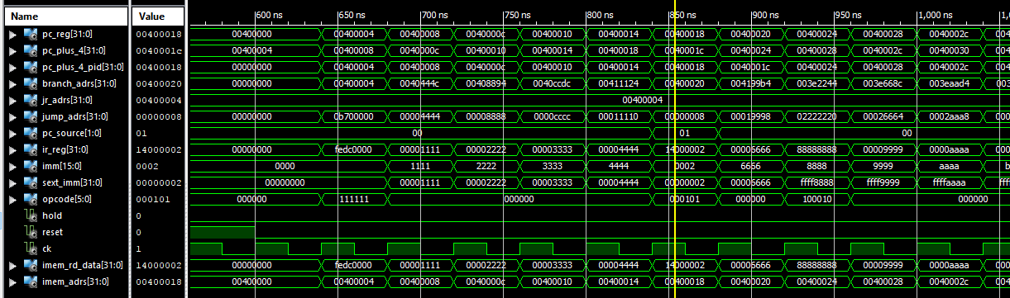

3.3) Say we have a value V in location Adrs in the IMem. What will be the expected values of the

PC_reg and PC_plus_4_pID signals when the IR_reg signal has the value V? Adrs? Adrs-4?

Adrs+4? Other? Explain your reply.

PC_reg = Adrs

PC_plus_4_pID = Adrs : whan PC_source = 00 or 01 or 11

PC_plus_4_pID = Adrs – 4 : when PC_source = 10 (JR instruction = x"00400004"(

3.4) In the IMem we have the value of a bne instruction (x"14000002") in address x”400014”.

Write down all of the fields of this instruction (opcode, Rs, ..., etc.) Do we expect to actually

branch? Who checks the condition?

Opcode = 000101

Rs = 00000

Rt = 00000

imm = x"02"

because the condition of bne is not met then branch_adr = PC + 4 = x"00400020"

because this is bne instruction then PC_source = 01 therefore PC = branch_adr = x"00400020"

3.5) Did we branch in the simulation? Check the simulation and write down the sequence of the

instructions (the PC_reg values) from address x”400008” until 4 addresses after reaching the

branch target.

Did the branch occur in the address we expect it to occur in (if this was a single cycle or

multi-cycle implementation)? Explain what happened.

Following this write the assembly code of the smallest possible loop (that is not an endless

loop, i.e., it decrements or increments a counter) and explain how it works.